

**GOVERNMENT OF TAMILNADU**

DIRECTORATE OF TECHNICAL EDUCATION, CHENNAI

NAAN MUDHALVAN SCHEME (TNSDC) SPONSORED

STUDENTS DEVELOPMENT PROGRAMME

ON

**IoT AND ITS APPLICATIONS**

**“DRAINAGE PROTECTION”**

**HOST INSTITUTION**

XXXX

DISTRICT - PINCODE

**TRAINING PARTNER**

**ENTHU TECHNOLOGY SOLUTIONS INDIA PVT LTD**

**DATE:**

|  |  |
| --- | --- |
| **NAME** | **ROLL NO** |
| Name 1 |  |
| Name 2 |  |
| Name 3 |  |
| Name 4 |  |
| Name 5 |  |
| Name 6 |  |

**Table of Contents**

|  |  |  |
| --- | --- | --- |
| **S No** | **Title** | **Page No** |
| **1** | **Abstract** | **1** |
| **2** | **Introduction** | **2** |
| **3** | **Components** | **2** |
| **4** | **Circuit Diagram** | **7** |
| **5** | **Code** | **8** |
| **6** | **Output Results** | **12** |
| **7** | **Cloud Output** | **13** |
| **8** | **Conclusion** | **14** |

**SMART DUSTBIN SYSTEM**

**ABSTRACT**

The Drainage Protection System using an IR sensor and a servo motor is designed to prevent blockages and overflow in drainage systems. The IR sensor continuously monitors the water level or detects obstructions within the drainage pipes. When the sensor detects a blockage or a high water level, it sends a signal to the servo motor, which then activates to open a drainage gate or control valve, allowing water to flow freely and preventing potential overflow or flooding. The system can also be integrated with WiFi and HTTP communication to send real-time alerts and status updates to a remote server, enabling timely intervention and maintenance. This automated solution is efficient and reliable, enhancing the safety and functionality of drainage systems in residential, commercial, and industrial areas. The use of a servo motor provides precise control over the drainage mechanism, ensuring responsive and effective protection against water-related issues. By integrating automation with real-time monitoring, the Drainage Protection System enhances the reliability and safety of drainage infrastructure, making it an essential component in modern urban planning and environmental management. This technology-driven approach not only improves the functionality of drainage systems but also contributes to safeguarding properties and communities from the adverse effects of water-related issues.

**INTRODUCTION**

The Drainage Protection System utilizing an IR sensor and a servo motor is an innovative solution designed to mitigate the risks of blockages and overflow in drainage systems. As urbanization and infrastructure development continue to grow, the efficiency of drainage systems becomes increasingly critical in preventing flooding, water damage, and other related issues. Traditional drainage systems often lack the capability to respond promptly to obstructions or rising water levels, leading to potential hazards. This system leverages an IR sensor to continuously monitor the water level or detect blockages within the drainage pipes. Upon detection, the sensor signals a servo motor to activate a drainage gate or control valve, effectively managing water flow and preventing overflow. The inclusion of WiFi and HTTP communication allows the system to send real-time alerts and status updates to remote servers, ensuring timely intervention and maintenance.

**Components**

1. ESP32 Microcontroller
2. Arduino IDE
3. IR Sensor
4. Servo Motor
5. USB Cable (B-Type)
6. Breadboard
7. Jumper Wire

**Hardware Description**

**i) ESP32**

The ESP32 is a highly versatile microcontroller developed by Espressif Systems, designed for a wide range of applications, particularly in the Internet of Things (IoT) space. It is renowned for its combination of high performance, integrated wireless connectivity, and a rich set of features, all at a low cost. The ESP32 is commonly used in projects that require both Wi-Fi and Bluetooth capabilities, making it suitable for smart home devices, sensor networks, and wearable technology.

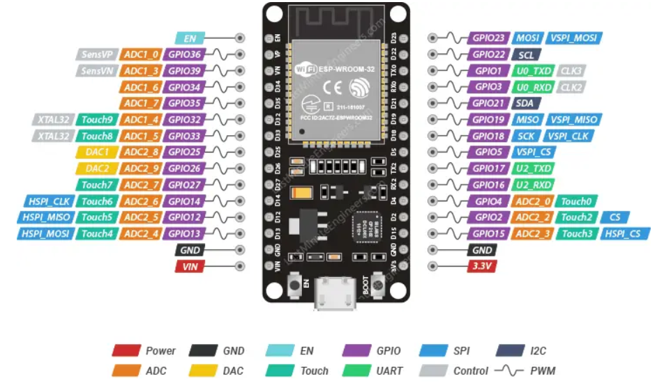

**Figure 1.1**

**Key Features**

* **Dual-Core Processor**: Features a dual-core Tensilica LX6 microprocessor running up to 240 MHz.
* **Connectivity**: Includes Wi-Fi (802.11 b/g/n) and Bluetooth (Classic and BLE).
* **Memory**: Typically comes with 520 KB of SRAM and supports external flash memory.
* **I/O Pins**: Offers numerous GPIO (General Purpose Input/Output) pins with various functionalities.
* **Peripherals**: Includes ADC, DAC, PWM, SPI, I2C, UART, and more.
* **Power Management**: Equipped with low-power modes for energy efficiency.

**ii) IR Sensor**

An Infrared (IR) sensor is an electronic device that detects and measures infrared radiation, typically emitted from an object. It consists of an IR LED that emits infrared light and a photodiode that receives it. When an object passes in front of the sensor, the IR light reflects back, and the photodiode detects the reflected light, triggering a response. IR sensors are widely used in various applications, including motion detection, proximity sensing, and object counting. They are valued for their simplicity, low cost, and ability to operate in low-light conditions. In projects like smart dustbins and drainage systems, IR sensors detect the presence of objects or water levels.

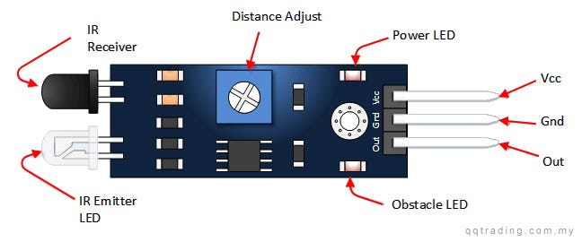

**Figure 1.2**

**Key specifications:**

* **Detection Range:** Up to 7 meters
* **Detection Angle:** 110 degrees
* **Operating Voltage:** DC 4.5V - 12V
* **Output Signal:** 3.3V digital output
* **Delay Time:** Adjustable from 0.3 seconds to 5 minutes
* **Operating Temperature:** -15°C to +70°C
* **Sensitivity:** Adjustable

**iii) Servo Motor**

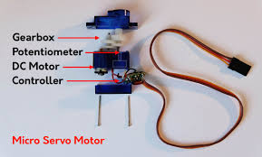A servo motor used with the ESP32 is a compact, precise actuator commonly employed in projects requiring controlled motion, such as robotics, automation, and smart systems. It operates using Pulse Width Modulation (PWM) to set the position of the motor shaft, typically ranging from 0 to 180 degrees. The servo motor has three wires: power, ground, and control, making it easy to interface with the ESP32. Operating at 4.8V to 6V, it offers torque sufficient for small to medium loads. Its precise control and ease of use make it ideal for applications like opening and closing mechanisms, robotic arms, and pan-tilt modules.

**Figure 1.3 Servo Motor**

**Key Features**

* **Operating Voltage:** 4.8V - 6V DC
* **Torque:** 1.5 kg.cm to 3.5 kg.cm (varies by model)
* **Rotation Range:** 0 to 180 degrees
* **Control Signal:** PWM (Pulse Width Modulation)
* **Pulse Width Range:** 1000µs to 2000µs
* **Operating Speed:** 0.1 to 0.2 seconds per 60 degrees (varies by voltage)
* **Gear Type:** Plastic or metal gears
* **Connector Type:** 3-pin (VCC, GND, PWM signal)
* **Operating Temperature**: -10°C to +50°C

**Circuit Diagram**

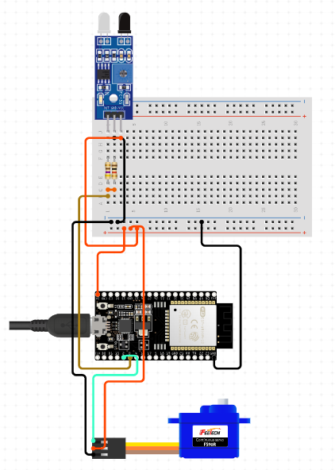

**Figure 1.4 Circuit Diagram**

**SOFTWARE DESCRIPTION**

**ARDUINO IDE**

The Arduino Integrated Development Environment (IDE) is a powerful and user-friendly software application designed to facilitate the programming and uploading of code to Arduino microcontroller boards. It serves as the primary interface for developing, compiling, and debugging Arduino sketches (programs), making it an essential tool for anyone working with Arduino hardware.

* **Simple Interface:** User-friendly and intuitive design, suitable for beginners and experts.
* **Cross-Platform:** Available for Windows, macOS, and Linux.
* **Board Support:** Compatible with various Arduino boards (Uno, Nano, Mega, etc.).
* **Built-in Libraries:** Extensive libraries for sensors, displays, motors, and more.
* **Serial Monitor:** Tool for real-time communication and debugging via serial data.
* **Sketch Management:** Easily manage, save, and organize Arduino sketches (programs).
* **Library Manager:** Browse, install, and manage external libraries effortlessly.
* **Basic Debugging Tools:** Includes Serial Monitor and error indicators.
* **Easy Compilation & Uploading:** Simple process to compile and upload code to the board.
* **Extensible:** Supports third-party plugins for additional features.
* **Beginner-Friendly:** Ideal for those new to microcontrollers and electronics.
* **Open Source:** Free to use, modify, and share, encouraging innovation.
* **Continuous Updates:** Regular improvements and new features from the Arduino team.
* **Versatile Applications:** Suitable for a wide range of projects, from simple to complex.

**CODE**

#include <WiFi.h>

#include <HTTPClient.h>

#include <ESP32Servo.h>

// WiFi credentials

#define WIFI_SSID "iPhone 12"

#define WIFI_PASSWORD "11223344"

// Server details

const char *serverUrl = "https://console.thingzmate.com/api/v1/device-types/dp001/devices/dp001/uplink"; // Replace with your server endpoint

String AuthorizationToken = "Bearer cb83313c7d82d7eaac16a658c73996b2"; // Replace with your token

// Pin definitions

#define IR_SENSOR_PIN 12  // IR sensor to detect water level or obstruction

#define SERVO_PIN 14      // Servo motor to control drainage mechanism

Servo myServo;  // Create a Servo object

void setup() {

  Serial.begin(115200);

  // Initialize the sensor and servo pin

  pinMode(IR_SENSOR_PIN, INPUT);

  myServo.attach(SERVO_PIN); // Attach the servo to the defined pin

  myServo.write(0); // Ensure the servo starts in the off position (0 degrees)

  // Connect to WiFi

  WiFi.begin(WIFI_SSID, WIFI_PASSWORD);

  Serial.print("Connecting to WiFi");

  while (WiFi.status() != WL_CONNECTED) {

    delay(1000);

    Serial.print(".");

  }

  Serial.println("Connected to WiFi");

}

void loop() {

  // Read sensor value

  int sensorStatus = digitalRead(IR_SENSOR_PIN);

  // Servo control based on sensor status

  if (sensorStatus == LOW) {

    myServo.write(90);  // Turn the servo motor to 90 degrees

    Serial.println("IR sensor detected. Servo turning to 90 degrees...");

  } else {

    myServo.write(0);   // Turn the servo motor off (0 degrees)

    Serial.println("IR sensor not detected. Servo turning off...");

  }

  // Prepare data for transmission

  String payload = "{\"sensor_status\":" + String(sensorStatus) + "}";

  // Send data to server

  HTTPClient http;

  http.begin(serverUrl);

  http.addHeader("Content-Type", "application/json");

  http.addHeader("Authorization", AuthorizationToken);

  int httpResponseCode = http.POST(payload);

  if (httpResponseCode > 0) {

    String response = http.getString();

    Serial.println("HTTP Response code: " + String(httpResponseCode));

    Serial.println(response);

  } else {

    Serial.print("Error code: ");

    Serial.println(httpResponseCode);

  }

  http.end(); // Free resources

  delay(3000); // Wait for 10 seconds before checking the sensor again

}

**OUTPUT**

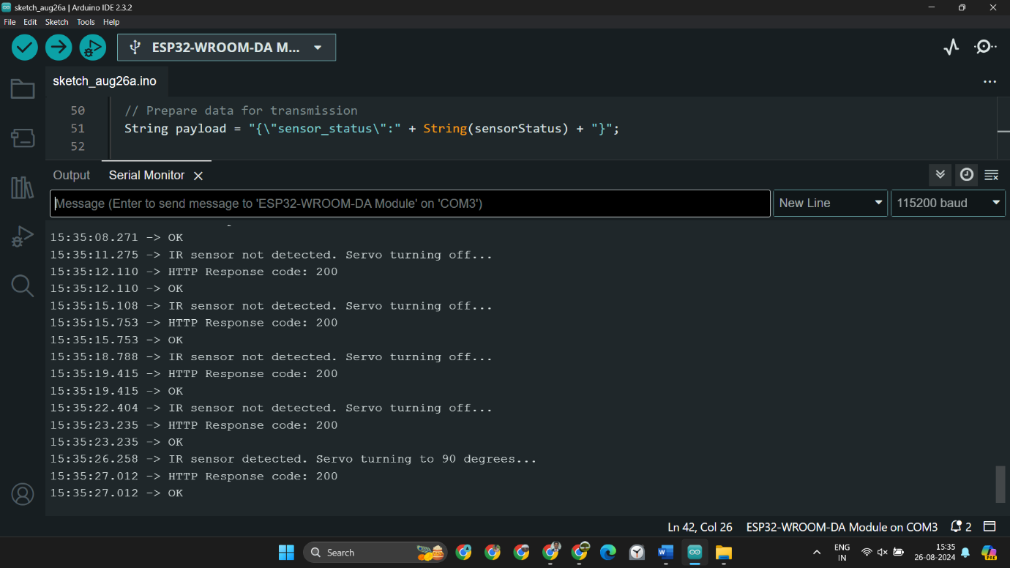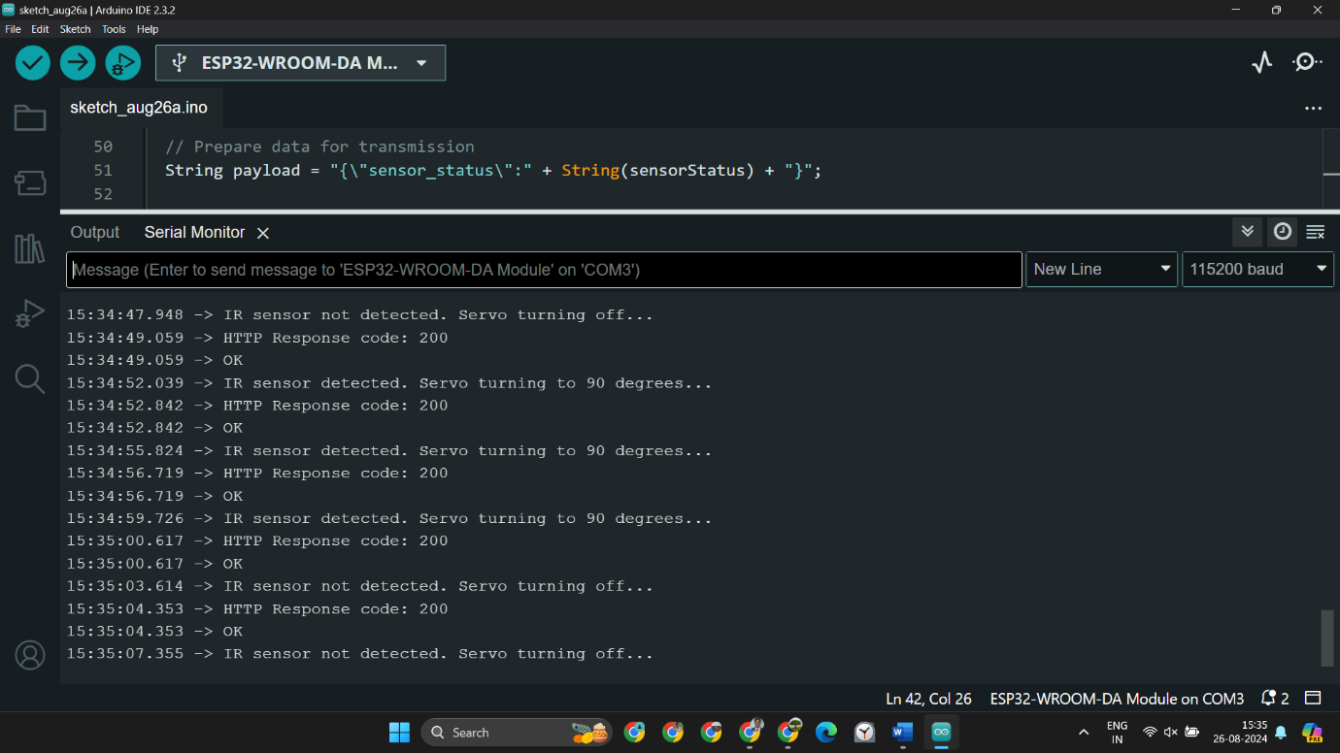

**Figure 1.5 A & B Drainage Protection**

**CLOUD OUTPUT**

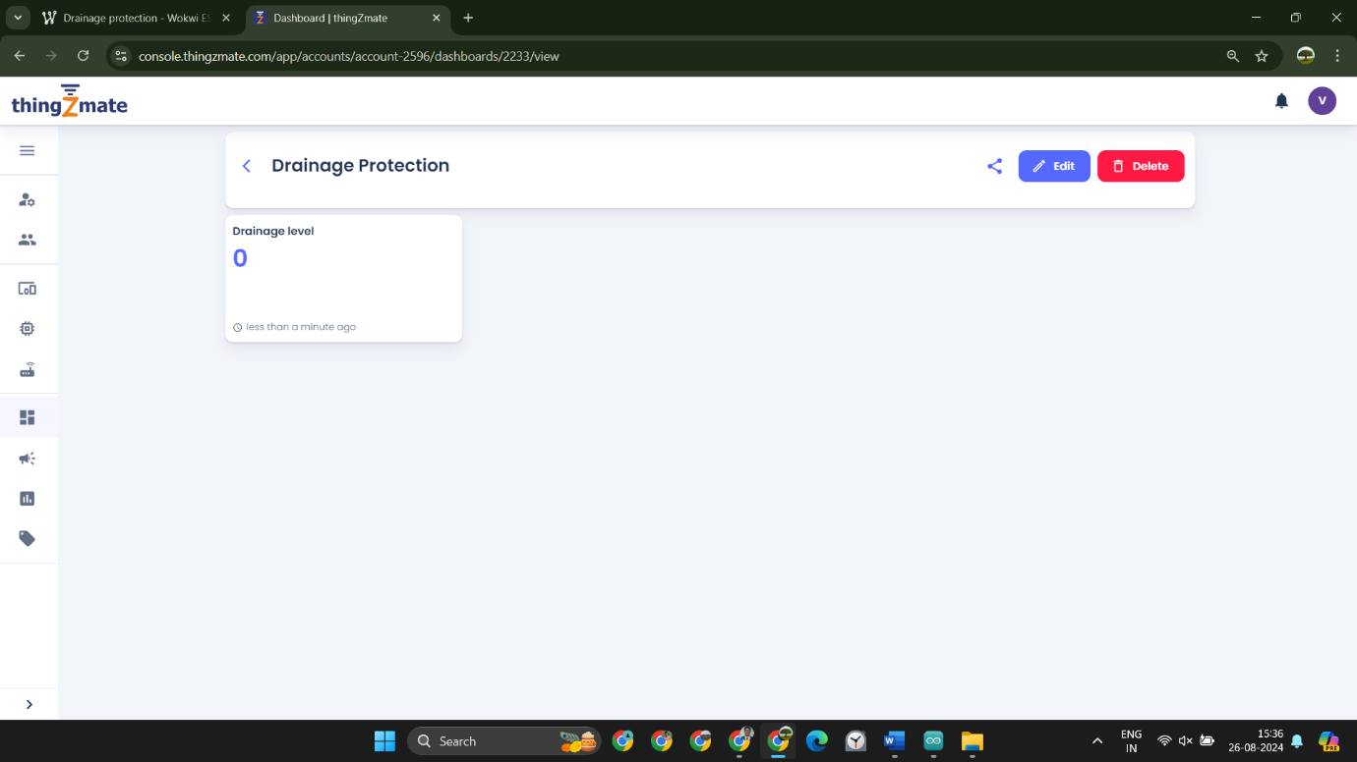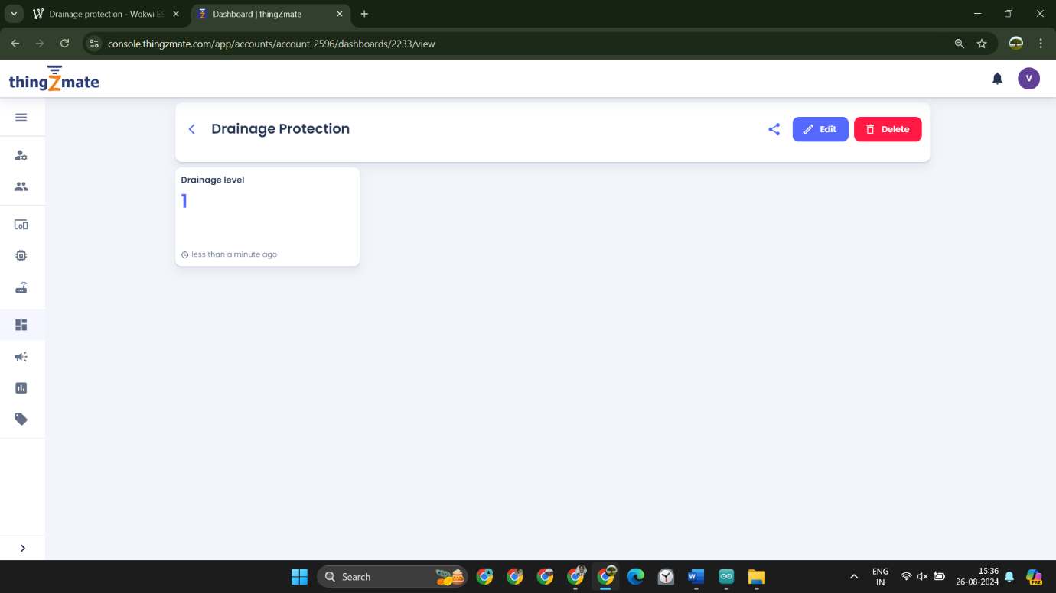

**Figure 1.6 A & B Cloud Output**

**CONCLUSION**

The Drainage Protection System, incorporating an IR sensor and a servo motor, offers a proactive and efficient solution to managing drainage systems and preventing potential blockages and overflows. By continuously monitoring water levels and detecting obstructions, the system ensures timely responses, significantly reducing the risk of flooding and water damage. The integration of automation with real-time data transmission via Wi-Fi and HTTP communication enables remote monitoring and swift intervention, making the system highly effective in both residential and commercial settings. This technology-driven approach enhances the reliability and safety of drainage infrastructure, providing peace of mind to property owners and managers. The precise control afforded by the servo motor allows for accurate management of water flow, ensuring that drainage systems operate optimally even under challenging conditions. In conclusion, the Drainage Protection System represents a critical advancement in environmental management and urban planning, offering a smart, responsive, and reliable solution to protect against water-related issues. It is an essential tool for modern infrastructure, contributing to the sustainability and resilience of urban environments.

**REFERENCE**

1. <https://forum.arduino.cc/t/getting-max30100-sensor-values-0-in-the-local-database/1241570>.
2. <https://wokwi.com/projects/363259672680856577>
3. <https://www.taylorfrancis.com/books/mono/10.1201/9781003147169/let-get-iot-fied-shriram-vasudevan-anudeep-juluru-murugesh>
4. <https://www.electronics-lab.com/superb-open-bee-compatible-esp32/>
5. <https://www.packtpub.com/en-nz/product/internet-of-things-from-scratch-9781837638543?type=print>